Joel Lantigua

Linux Administrator

Using Awk command

9/29/22

Awk

Before I started on this assignment, I had to download the **AwkLab.data** file onto my host computer. Once the download was completed, I then needed to open the command prompt so that I can send the file to my Ubuntu server using the command **scp -r AwkLab.data** **joel@192.168.241.136:/home/joel/Sharetoserver** As you can see below the data file named **AwkLab.data** was successfully sent to my **Sharetoserver** folder.



Next, I switched over to my ubuntu server and use the command **ls** to check if the **Sharetoserver** folder is there. Once I see that the folder is there, I use the command **cd Sharetoserver** to change into the directory. Now if I use the command **ls** I should be able to see the **AwkLab.data** file.

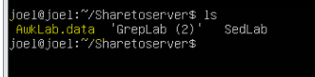

Question 1, Print all the First Names? for this question I used the command **awk ‘{print $1}’ AwkLab.data.** we only wanted the first name so that’s where we use ‘{print $1}’ The $1 mean the first part of the format of the file which is the first names.

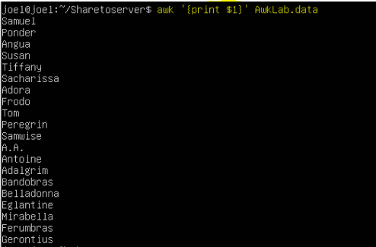

Question 2, Print phone numbers for Tom and Frodo after their names? For this question I used the

command **awk ‘/Tom|Frodo/{print $1 $2 $3}’ FS=, AwkLab.data**. First I used **Tom|Frodo** the ”**|**” means to search for both Tom and Frodo. I then used $1 for the first name, then I use the $2 to represent their last names. Next, I used the $3 which will represent the phone number. The **Fs=** means that thid id a field separator since we are looking for Tom and Frodo.



Question 3, Print Peregrin's full name and phone number area code only? In this question I used the command **awk ‘/Peregrin/{print $1 $2 }’ Fs=­, AwkLab.data.** I first started with **‘/Peregrin/** the “ / “ helps find line matches in this case I needed to look for **Peregrin**. Next, I used **{print $1 $2 }’** the $1 represents the full name of Peregrin and the **$2** represents the area code. I also used **Fs=,** just to give space between the two fields that were printed.



Question 4, Print all phone numbers in the 123 area code along with the names? **awk ‘/(123)/{print$1 $2 $3 $4}’ FS=- AwkLab.data.** I first used **‘/(123)/** since I needed phone numbers that start in 123. Next, I used **{print$1 $2 $3 $4}’** the **$1** is used for the full name, then I used **$2** to represent the area code of the phone number, next was **$3** to represent the middle three digits of the phone number and **$4** to represent the last four digits of the phone number. For some reason the **$4** prints out an extra 3 numbers after the last four digits of the phone possibly because of the format of the file.

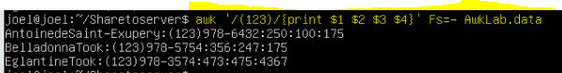

Question 5, Print all Last names beginning with either a T or D? For this question I use the command **awk ‘$2~/(T|D)/{print $2}’ AwkLab.data.** I first started with **‘$2~/** in this casethe **$2~** represents the last names that matches the field input. Then I used **(T|D)** this mean anything that starts with T or D in last names. Next I used **{print $2}’** to print out the last names. Unfortunately, there wasn’t anyone with a last name that starts with a D and when I doing this it also printed out the area code as well.

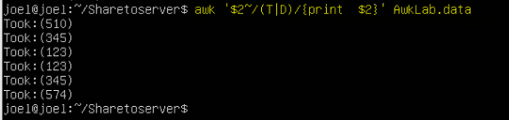

Question 6, Print all first names containing four or less characters? In this question I use the command **awk ‘{if(length($1)<=4){print $1}}’ AwkLab.data .** This command means that if the length of **$1** which represents the first name is less than or equal to 4 which represents characters in the name, then print out the **$1** aka the names.



Question 7, Print the first names and area codes of all those in the 916 area code? For this question I used the command **awk ‘/(916)/{print $1 $2}’ Awklab.data**. I first started with **‘/(916)/** which means match any line that has 916. Then I used **{print $1 $2}’**  to print out the names and the area code. In this command the **$1** represents the names and the **$2** represents the area code.



Question 8, Print Sacharissa's campaign contributions following her name? For this question I used the command **awk -F: ‘/Sacharissa/{print $1 “$” $3, “$”$4 “$”$5}’ AwkLab.data.** I first used the **-F:** which is used as a separator for the values. Then I used **‘/Sacharissa/** for the line matching that name. Next I used {**print $1 “$” $3, “$”$4 “$”$5}’**  the **$1** represents the first name, next I inserted a **“$”** to place that symbol in front of the first contribution which is represented by **$3** the I did the same with **$4 and $5**. The **$4** represents the second contribution and the **$5** represents the third contribution.



Question 9, Print last names followed by a comma and the phone number? For this question I used the command **awk -F “[ :]” ‘{print $2 “, ” $3 $4}’ AwkLab.data** first I started with **-F “[ :]”** to separate the first name form the last name. Then I used **‘{print $2 “, ” $3 $4}’** the **$2** represents the last names, followed by **“, ”** to insert the comma. Next I inserted **$3** which represents are code and the **$4** represent the rest of the phone number.

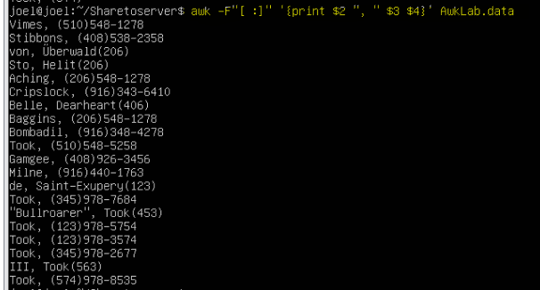

Question 10, Print the first and last names of those who contributed more than $110 in the last month? For this question I sued the command **awk -F ‘[: ] ‘ ’ {if(($7)>+110) {print $1, $2, $7}}’ AwkLab.data.** I first used **-F ‘[: ] ‘ ’** to create space, then I used **{if(($7)>+110)** which means if **$7** aka last month contribution is greater than 110 then print. To print the results I used **{print $1, $2, $7}}’** the **$1** represents the first name and the **$2** represents the last names lastly the **$7** which is the last moth contribution.

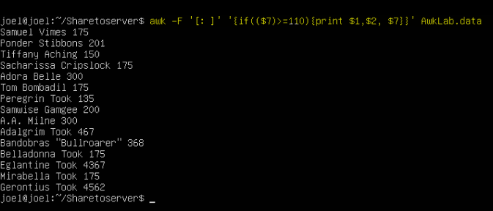

Question 11, Print the last names, phone numbers, and first month contribution of those who contributed less than $150 in the first month? In this question I used the command **awk -F ‘[: ]’ ‘{if (($5)<=150){print $1, $2, $3,$4, $5}}’ AwkLab.data** the first thing I used the **-F ‘[: ]’**  to create space, Then I used **‘{if (($5)<=150)** this means that if **$5** which represents the first moth contribution is less than 150 print. Next I printed the result by using **{print $1, $5}}’** the **$1 and $2** represents the full name and **$3 and $4** represents the phone number.



Question 12, Print the first names and contribution of those who contributed between $10 and $200 in the first month? For this question I used the command **awk -F “:” ‘$5<=200 && $5>=10 {print $1, $5}’ AwkLab.data** I first started with **-F “:”** for space creation, then I used **‘$5<=200** which mean if **$5** is less than or equal to **200**. Next I used **&&** to add another operation, then I added **$5>=10** so this means if **$5** is grater than **10** print. Lastly I added  **{print $1, $5}’** the **$1** represents the full name and the **$5** represents the first month contribution.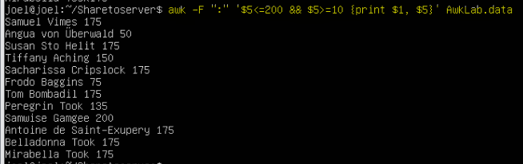

Question 13, Print the first name, last names and total contributions of those who contributed less than $700 over the three-month period? For this command I used **awk -F ‘[: ]’ ‘{if(($5+$6+$7)<700) {print $1,$2, ($5+$6+$7)}}’ AwkLab.data** I started with the space creator then I used **‘{if(($5+$6+$7)<700)** this mean that if all contributions added up is less than 700 then print. **$5** represents the first contribution, **$6** represents the second contribution and the **$7** represents the last contribution. Then to print my result I added **{print $1,$2, ($5+$6+$7)}}’** the **$1 and $2** represents the full name.

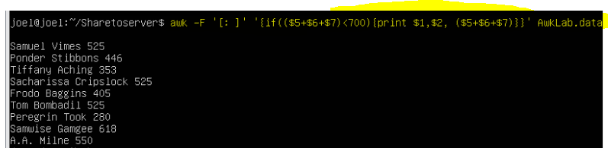

Question 14, Print the first names and first letter of the last name, and average contribution of those who had an average contribution of more than $300? For this question I started with a space creator then I added **‘($5+$6+$7)/3>300** which mean that if all contributions added up and then divide the sum by 3 which would be the average. Then if the average is grater than 300 print. For the printing I used **{print $1, $5+$6+$7/3}’** the **$1** represents the first name then **$5+$6+$7/3** would be the average contribution.

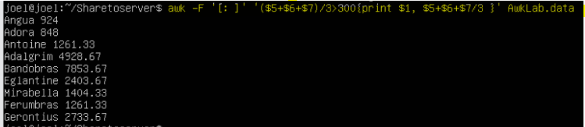

Question 15, Print the last name and area code of those not in the 916 area code? For this question I used the command  **awk -F ‘[: ]’ ‘!($3==“(916)” ){print $2, $3 $4}’ AwkLab.data** I first started with the space creators then I used **‘!($3==“(916)” )** first **!** means anything that’s not equal to the input field which means that if **$3** which represents the area code is equal to 916 then don’t print it. Next I used **{print $2, $3 $4}’** in this case the **$2** represents the last name, then **$3 and $4** represents the phone number.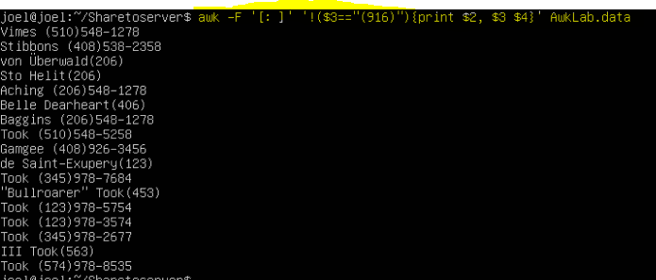

Question 16, Print each record preceded by the number of the record? For this question I used the command **awk ‘{ print NR,$0}’ AwkLab.data** this was fairly simple I used **‘{ print NR,$0}’** NR is the total number of records followed by **$0** which represents the whole line.

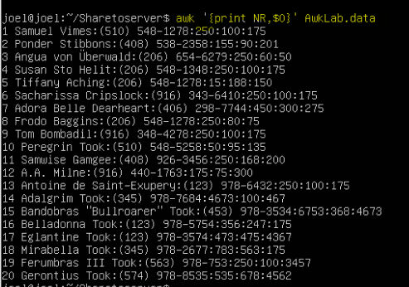

Question 17, Print the name and total contribution of each person? For this question **awk -F ‘[: ]’ ‘{print $1, $2, $5+$6+$7}’ AwkLab.data** I first started with the space creators then I used **‘{print $1, $2, $5+$6+$7}’** the **$1 and $2** represents the name. Then **$5+$6+$7}’** are all the 3 contributions added up.

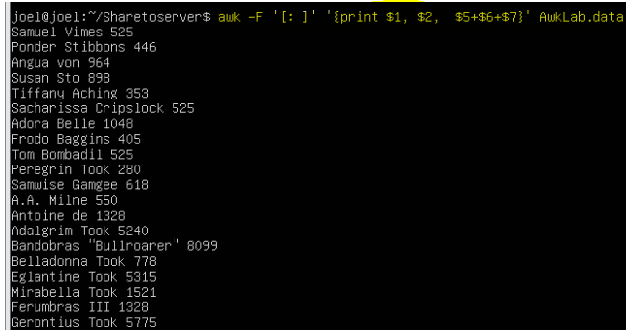

Question 18, Add $10 to Tiffany Aching’s first contribution and print her full name and first contribution? For this question I used the command **awk -F ‘[: ]’ ‘/^\<Tiffany Aching\>/{$5=$5+10;Print}’ AwkLab.data** I first used the space creator then I used **‘/^\<Tiffany Aching\>/** the **^** is used to match any character inserted which was **Tiffany Aching.** Next I used **{$5=$5+10;Print}’** meaning take **$5** which is the first contribution and at **10** to it as you can see in the screen shot below the first contributions now at 25.



Question 19, Change Samwise Gamgee’s name to Sean Astin? For this question I used the command **awk -F ‘[: ]’ ‘$1==”Samwise” && $2==”Gamgee”{$1=“Sean”;$2=“Austin”;print $1, $2, $3}’ AwkLab.data** I used **‘$1==”Samwise” && $2==”Gamgee”** as you **$1** equals **Samwise and $2** equals **Gamgee.** Next, I used **”{$1=“Sean”;$2=“Austin”;print $1, $2, $3}’** basically saying take **$1** and change it to **Sean** then take **$2** and change it to **Austin**. Lastly I printed **$1**  which is first name then I printed **$2** which is last name and then I added **$3** to show the area code to show that everything else stayed the same but the name.



Question 20, Write an awk script to do the following (MUST be an awk script not just a bash script or commands on the command line) (a) Prints first name of the all the Tooks followed by their total campaign contributions . (b) Print the full names and contributions of anyone who contributed between $10 and $200 in the last contribution (c) Prints the full names and average contribution of those who contributed less than $300 on average 2? For this script I first started by making a script file by using **nano awk.sh** I named the file **awk.sh**

Once the nano created and opened the text editor I started with **#!/bin/awk -f** this tells the script that its going to be a awk script. Next, I used the command **‘$2~/^(T)/{print $2}’** This command shows the people with the **tooks** last name. since I know that in the file the only last names that starts with a T are “Tooks”. Next I used **{print $2}’** to print the last names. The next command I used was **‘$5<=200 && $5>=10 {print $1, $5}’** I first started **‘$5<=200** which mean if **$5** is less than or equal to **200**. Next I used **&&** to add another operation, then I added **$5>=10** so this means if **$5** is grater than **10** print. Lastly I added  **{print $1, $5}’** the **$1** represents the full name and the **$5.** The last command I used was For this question I started with a space creator then I added **‘($5+$6+$7)/3>300** which mean that if all contributions added up and then divide the sum by 3 which would be the average. Then if the average is grater than 300 print. For the printing I used **{print $1, $5+$6+$7/3}’ the** **$1** represents the first name then **$5+$6+$7/3** would be the average contribution. I the used control x to save the script.

Once I saved the script I the needed to give the script executable commands by using the command **chmod +x LAB.awk** this will allow the script to be executable. One way to check if this actually worked is by using the **ls** command and if you see the file highlighted green then it successfully worked.

Now that we have given the file executable rights, we can now run the script by using **./LAB**.awk you can see in the screenshot below the script has printed all three results. Unfortunately, I could not figure out how to delete the duplicate lines. I tried using **!seen[$0]++** and a couple other ways but couldn’t figure it out. Also I had difficulty with the printing pattern. When done on a bash script my script will print all results as asked for…

Work Cited

<https://www.gnu.org/software/gawk/manual/html_node/Field-Separators.html>

<https://www.gnu.org/software/gawk/manual/html_node/Field-Separators.html>

<https://linux.die.net/man/1/awk>

<https://www.gnu.org/software/gawk/manual/html_node/Bracket-Expressions.html>

<https://www.rockyourcode.com/how-i-remove-duplicate-lines-from-a-file-with-awk/>